***Dt : 20/10/2022***

***Ex-program(Demonstrating "Anonymous InnerClass as class extention")***

***PClass.java***

***package test;***

***public class PClass {***

***public void m1(int x) {***

***System.out.println("====PClass m1(x)====");***

***System.out.println("The value x:"+x);***

***}***

***public void m2(int y) {***

***System.out.println("====PClass m2(y)====");***

***System.out.println("The value y:"+y);***

***}***

***}***

***DemoAnonymous1.java(MainClass)***

***package maccess;***

***import test.*;***

***public class DemoAnonymous1 {***

***public static void main(String[] args) {***

***//Anonymous InnerClass as Class extension***

***PClass ob = new PClass()***

***{***

***public void m1(int x) //Overriding method***

***{***

***System.out.println("====CClass m1(x)====");***

***System.out.println("The value x:"+x);***

***}***

***public void m3(int z) //Non-Overriding method***

***{***

***System.out.println("====CClass m3(z)====");***

***System.out.println("The value z:"+z);***

***}***

***};***

***ob.m1(11);***

***ob.m2(12);***

***// ob.m3(13);***

***}***

***}***

***o/p:***

***====CClass m1(x)====***

***The value x:11***

***====PClass m2(y)====***

***The value y:12***

***---------------------------------------------------------------***

***Execution flow of above program:***

***ClassFiles:***

***PClass.class***

***DemoAnonymous1.class(MainClass)***

***DemoAnonymous1$1.class***

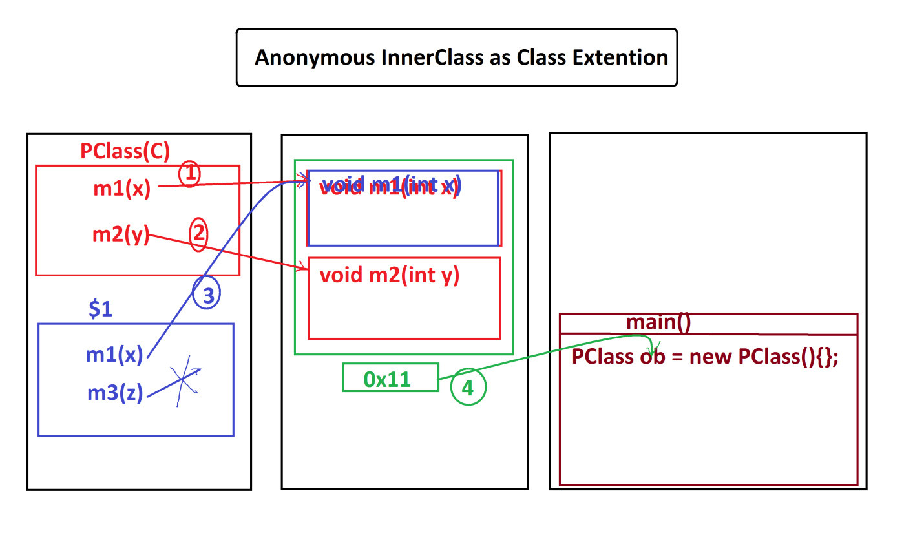

***===============================================================***

***Ex-Program(Demonstrating "Anonymous InnerClass as Implementation class")***

***ITest.java***

***package test;***

***public interface ITest {***

***public abstract void m1(int x);***

***public default void m2(int y) {***

***System.out.println("====default m2(y)====");***

***System.out.println("The value y:"+y);***

***}***

***}***

***DemoAnonymous2.java(MainClass)***

***package maccess;***

***import test.*;***

***public class DemoAnonymous2 {***

***public static void main(String[] args) {***

***//Anonymous InnerClass as implementation class***

***ITest ob = new ITest()***

***{***

***public void m1(int x)//Implemented and Overriding method***

***{***

***System.out.println("====method m1(x)====");***

***System.out.println("The value x:"+x);***

***}***

***public void m3(int z)//Non-Implemented and Non-Overriding method***

***{***

***System.out.println("====method m3(z)====");***

***System.out.println("The value z:"+z);***

***}***

***};***

***ob.m1(11);***

***ob.m2(12);***

***//ob.m3(13);//Error***

***}***

***}***

***o/p:***

***====method m1(x)====***

***The value x:11***

***====default m2(y)====***

***The value y:12***

***-------------------------------------------------------------***

***Execution flow of above program:***

***ClassFiles:***

***ITest.class***

***DemoAnonymous2.class(MainClass)***

***DemoAnonymous2$1.class***

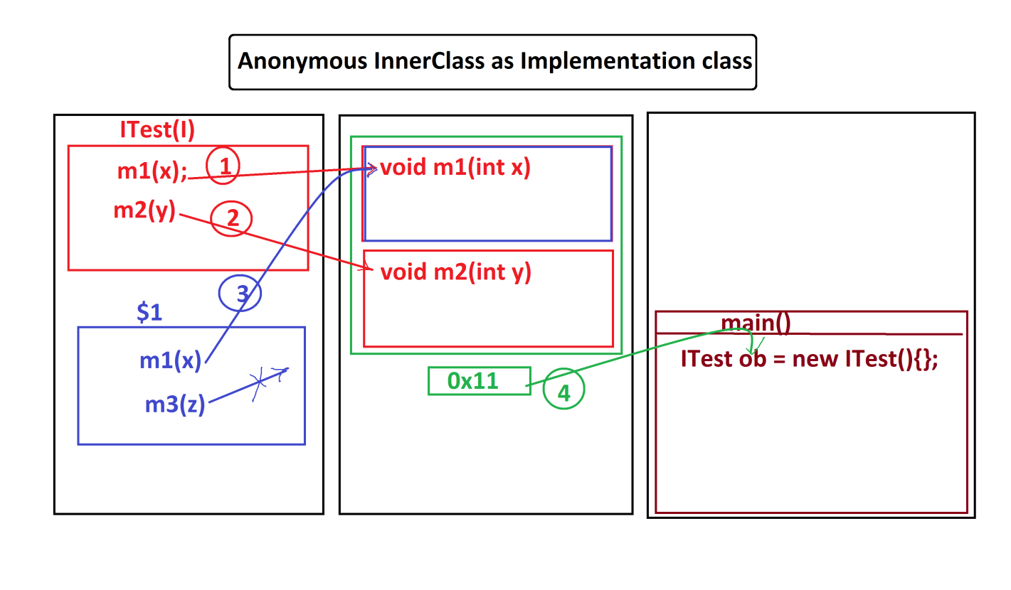

***==================================================================***

***Note:***

***=>Generalization process using Classes model is modified as "Anonymous***

***InnerClass as Class Extention".***

***=>Generalization process using Interfaces model is modified as "Anonymous***

***InnerClass as Implementation class"***

***========================================================================***

***Ex-Program:***

***Convert IComparable application into "Anonymous InnerClass as implementation***

***class model"***

***=>GreaterValue and SmallerValue classes as Anonymous***

***IComparable.java***

***package test;***

***public interface IComparable {***

***public abstract int compare(int x,int y);***

***}***

***DemoAnonymous3.java(MainClass)***

***package maccess;***

***import test.*;***

***import java.util.*;***

***public class DemoAnonymous3 {***

***public static void main(String[] args) {***

***Scanner s = new Scanner(System.in);***

***System.out.println("Enter the value of x:");***

***int x = s.nextInt();***

***System.out.println("Enter the value of y:");***

***int y = s.nextInt();***

***System.out.println("====Choice====");***

***System.out.println("1.GreaterValue\n2.SmallerValue");***

***System.out.println("Enter the Choice:");***

***switch(s.nextInt())***

***{***

***case 1:***

***//Anonymous InnerClass as implementation class***

***IComparable gv = new IComparable()***

***{***

***public int compare(int x,int y) {***

***if(x>y) return x;***

***else return y;***

***}***

***};***

***int r1 = gv.compare(x, y);***

***System.out.println("GreaterValue:"+r1);***

***break;***

***case 2:***

***//Anonymous InnerClass as implementation class***

***IComparable sv = new IComparable()***

***{***

***public int compare(int x,int y) {***

***if(x<y) return x;***

***else return y;***

***}***

***};***

***int r2 = sv.compare(x, y);***

***System.out.println("SmallerValue:"+r2);***

***break;***

***default:***

***System.out.println("Invalid choice....");***

***}//end of switch***

***s.close();***

***}***

***}***

***-----------------------------------------------------------------------***

***ClassFiles:***

***IComparable.class***

***DemoAnonymous3.class(MainClass)***

***DemoAnonymous3$1.class***

***DemoAnonymous3$2.class***

***======================================================================***

***Assignment-1:***

***Convert IArithmetic application into "Anonymous InnerClass as implementation***

***class" model.***

***=>Addition,Subtraction,Multiplication,Division,NodDivision classes as***

***Anonymous***

***Assignment-2:***

***Convert BankTransaction application into "Anonymous InnerClass as***

***implementation class" model.***

***=>WithDraw and Deposit classes as Anonymous***

***===================================================================***